PayslipStore_{.com}
Order Form

Order Category
Place order for:
Personal Details
Title*:
Full Name*:
Date of Birth:
Mailing Address*:
Post Code*:
Phone*:
Email*:
Fax:
N.I. Number*:
Employment Details
Employer Name*:
Employer Address*:
Post Code*:
Job Start Date:
Annual Salary*:
Salary Amount type:
Salary Paid by*:
Payslip Details
Payslip Name*: (Payslip List)
Payslip Type*:
Quantity*:
Date From*:
Date Until*:
P60 Details
P60 Name*: (P60 List)
Gross Pay*:
Tax Office Name:
Tax Office Ref. No:
Extra Fields (£5.00 Per field)
Bonus:
Commission:
Overtime:
Department:
Car Allowance:
Other/Name:
Delivery Details
Delivery Address:
Post Code:
Next Day Delivery (Monday to Friday) Before 9am (£13.75):
Next Day Delivery (Monday to Friday) Before 1pm (£8.75):
E-Delivery:
Feedback
Where did you hear about us?*:
Specific Instructions:

Payslips

Security Dot Matrix Payslips With Address (Our Rating: Quality 9 Out of 10)
These payslips will be printed by a Supreme Dot Matrix printer. Security Payslip comes in a security sealed envelope with your address on it. We work out all the Tax and NI for you. These payslips are among the second best category in our website.
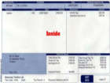  PR01 | 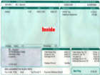  PR05 | 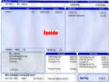  PR06 | 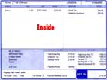  PR07
Security Dot Matrix Payslips Without Address (Our Rating: Quality 8.5 Out of 10)
These payslips will be printed by a Supreme Dot Matrix printer. We work out all the Tax and NI for you.
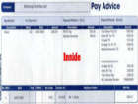  PR02 | 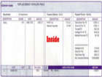  PR03 | 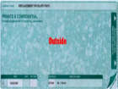  PR04
Sage Laser Payslips With Address & Non Security Version (Our Rating: Quality 9 Out of 10)
These SAGE payslips will be printed by a 3600 DPI Laser printer. We work out all the Tax and NI for you. These payslips are among the second best category in our website.
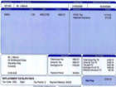  PR12 | 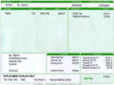  PR13 | 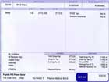  PR18 | 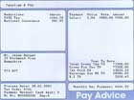  PR19
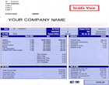
PR23
Dot Matrix Basic Payslips Comes Without Address & Non Security Version (Our Rating: Quality 8 Out of 10)
These payslips will be printed by a Supreme Dot Matrix printer. We work out all the Tax and NI for you.
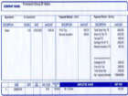  PR14 | 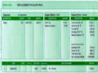  PR16 | 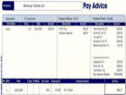  PR17 | 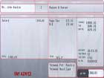  PR20
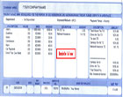
PR22

Laser Payslips Without Address & Non Security Version (Our Rating: Quality 8 Out of 10)
These payslips will be printed by a 3600 DPI Laser printer. We work out all the Tax and NI for you.
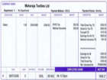  PR15 | 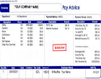  PR25
Laser Payslips Without Address & Non Security Version (Our Rating: Quality 8 Out of 10)
These payslips will be printed by a 3600 DPI Laser printer. We work out all the Tax and NI for you. These payslips are among the BEST category in our website. This Laser Security Payslip comes in a security sealed envelope with your address on it.
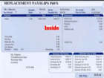  PR09 | 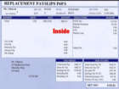  PR10 | 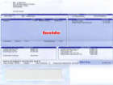  PR11 | 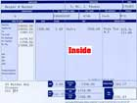  PR21
Best Of The Best Security Range Laser Payslips (Our Rating: Quality 10 Out of 10)
These payslips will be printed by a 3600 DPI Laser printer. This payslip is a custom made payslip, which will allow you to add Company Address, Company Logo, Bank Details, etc! Addition of adding a company logo or any other information will cost you £5.00(Cost varies depends on the information you want to add on your payslips).
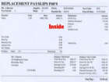  PR08 | 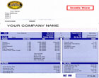  PR24

P60s

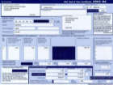  [P60-1] - Laser Landscape | 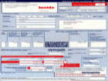  [P60-2] - Portrait Security | 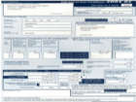  [P60-3] - Portrait Dot Matrix | 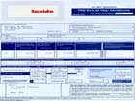  [P60-4] - Laser Security

